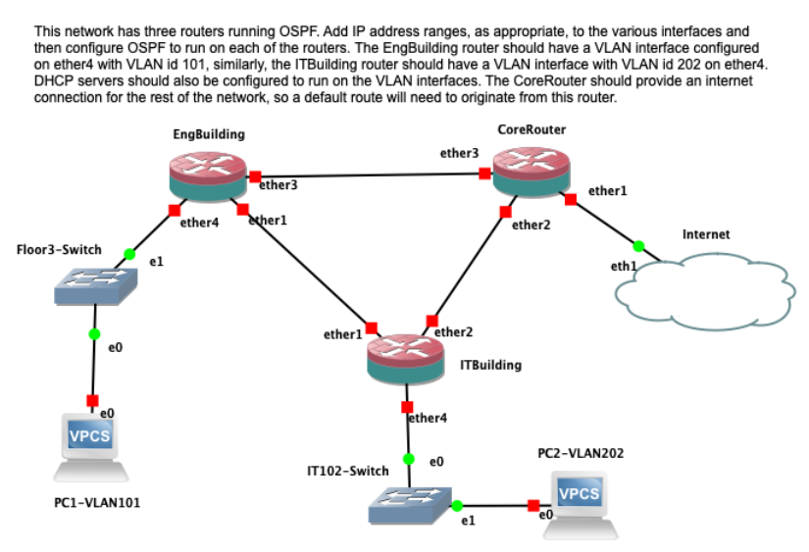

This network has three routers running OSPF. Add IP address ranges, as appropriate, to the various interfaces and then configure OSPF to run on each of the routers. The EngBuilding router should have a VLAN interface configured on ether4 with VLAN id 101, similarly the ITBuilding router should have a VLAN interface with VLAN id 202 on ether4. DHCP servers should also be configured to run on the VLAN interfaces. The CoreRouter should provide an internet connection for the rest of the network, so a default route will need to originate from this router.

Connections:

add interface=ether4 name=IT102 vlan-id=202

/ip dhcp-client;  
add

/ip pool  
add name=dhcp_pool0 ranges=192.168.1.2-192.168.1.254

1: Assign suitable private IP ranges and addresses on the links between the routers and on the VLAN interfaces as required.-

2: Setup DHCP Servers for each of the VLAN interfaces so that any clients devices on those VLANs can be configured using DHCP.-

3: Verify that the routers can ping each other over the direct links between each router.-

4: Add loopback interfaces on each of the routers and assign suitable IP addresses to these interfaces.-

5: Setup OSPF on each of the routers and use the Loopback interface address as the OSPF router id in each case.-

6: Set the values for the OSPF hello-interval to be 1 second and the dead-interval to be 5 seconds on each router.-

7: Configure each router to redistribute connected networks into the OSPF routing process.-

8: Verify that each router can then ping the Loopback address on each othe other routers and that the two PCs can ping each other.

9: Redistribute the default route from the CoreRouter into the OSPF routing process.

10: Add a NAT rule on the CoreRouter to ensure that traffic leaving the network via the Cloud device is handled properly.

11: Verify that the internet is reachable from all devices and explain the meaning of each entry in the routing table of the CoreRouter.

12: Explain what would happen if each router was not setup to redistribute connected networks, this was done in Step 7.

13: Do a trace (using ICMP) from PC1-VLAN101 to PC2-VLAN202 and explain the route that is taken.

14: Run a long ping (for 30 seconds) from the PC1-VLAN101 to PC2-VLAN202 and while this is running suspend the link (right click on the link to see this option) from the EngBuilding router to the ITBuilding router.

15: Are any pings dropped after the link is suspended? How long does it take for the ping to work again? Redo the trace, done in Step 13, and explain the results.

16: Run a packet capture on the link from the EngBuilding router to the CoreRouter, this should launch Wireshark on your computer.

17: Resume the link from the EngBuilding router to the ITBuilding router and wait about 30 seconds to ensure that OSPF has detected the topology change and reconverged.

18: Stop the packet capture and apply a display filter in Wireshark to only display OSPF packets. Explain the contents of any Link State Announcement (LSA) packets captured

Submit your work in a single zip file using the name format assignment2_firstname_lastname.zip - other file formats will NOT be accepted and email submission will NOT be accepted. Include related screen shots of your GNS3 simulation, the router configurations, as well as screen shots of your testing, results and related answers into a single document, this document (in Word or PDF format) can then be included in the zip file for submission. Please note that you do not need to submit the GNS3 project files. If you submit more than one attempt then only the last attempt will be marked.